**Assignment 4: Resolve Merge Conflicts**

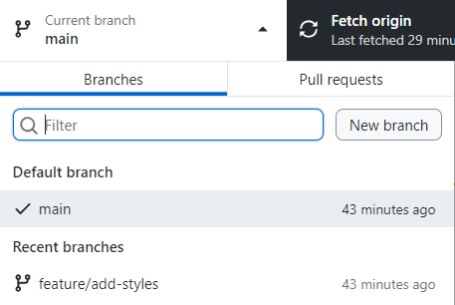

1. **Create a branch**:
   * Create a **new branch** called **feature/add-content**.

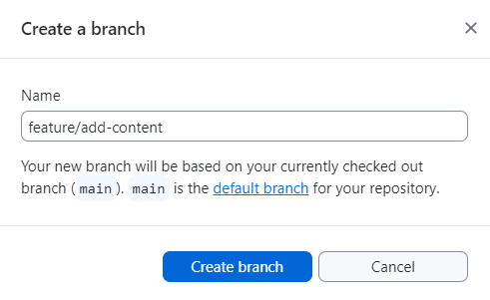

1. **Add content**:
   * In **index.html**, add a paragraph inside the **<body>:**

<p>This is some new content.</p>

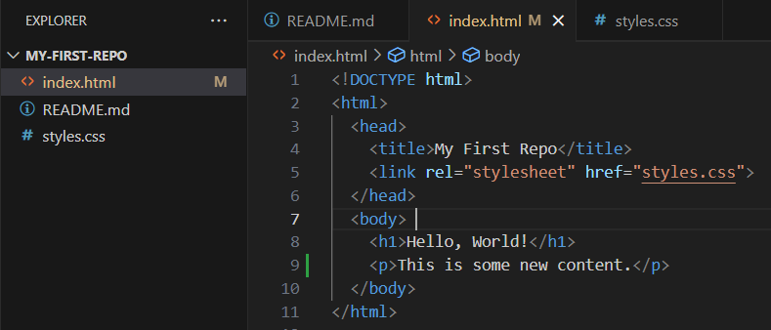  
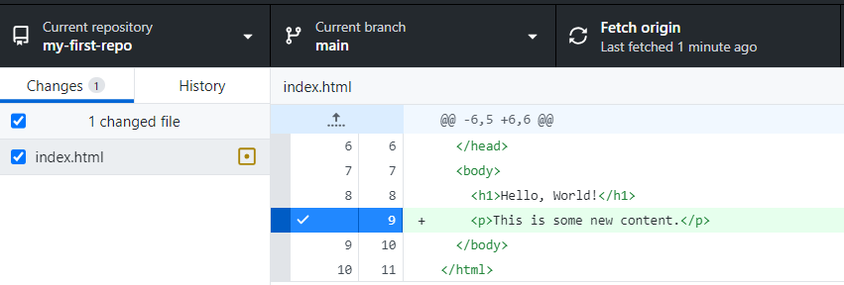

* + **Commit** and **push** the changes.  
    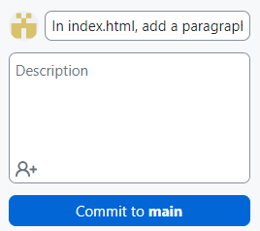

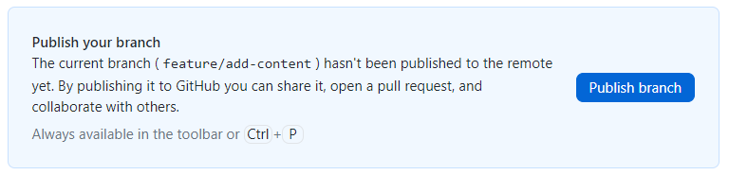

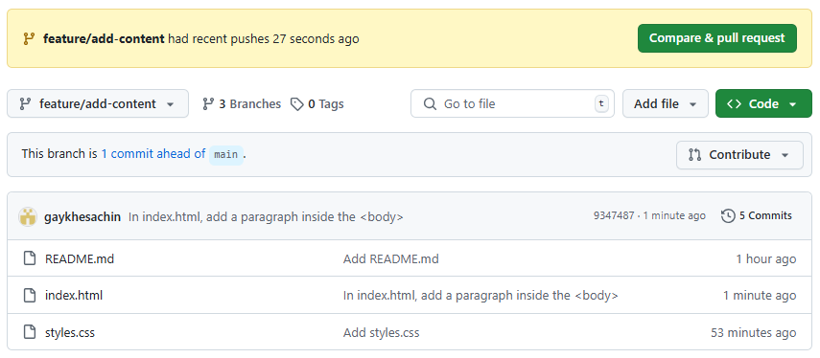

1. **Switch to main and make changes**:
   * Switch back to the **main branch**.  
     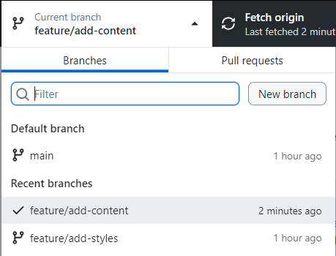
   * Edit the same part of **index.html** (e.g., change the paragraph text).  
     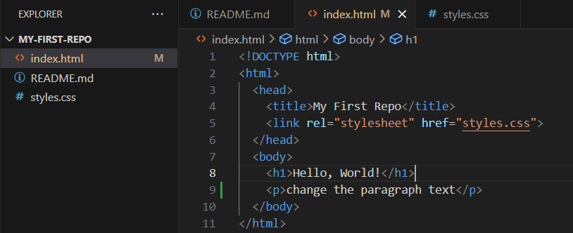

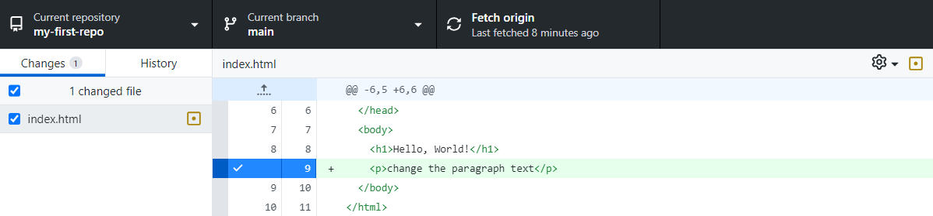

* + **Commit** and **push** the changes.  
    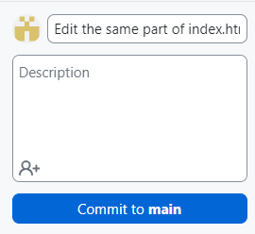

1. **Merge and resolve conflicts**:
   * Try to merge**feature/add-content** into **main**.  
     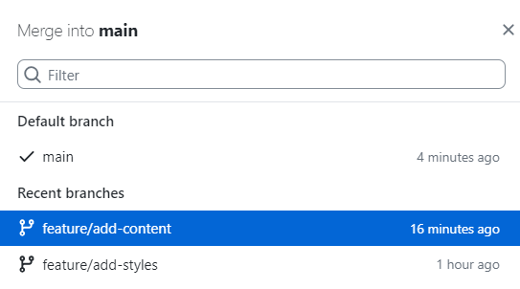  
     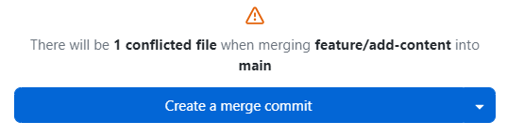
   * GitHub Desktop will show a **conflict**. Open the file and resolve the conflict by choosing the correct changes or combining them.

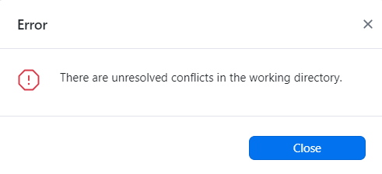

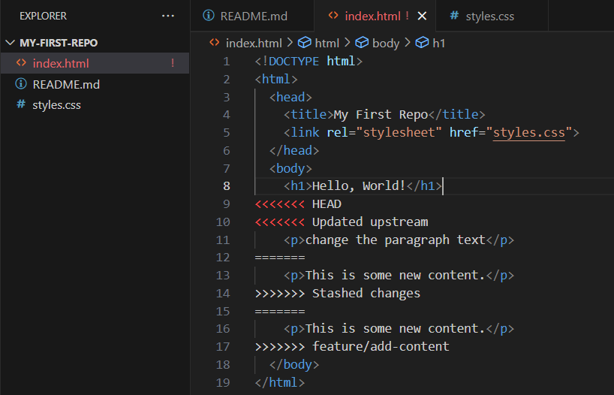

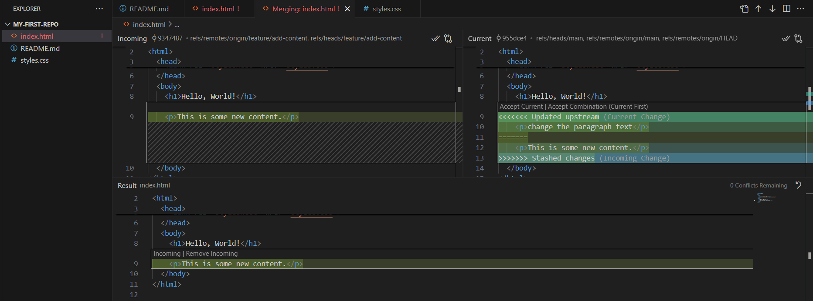

* + Mark the **conflict as resolved**, commit the **merge**, and **push**.

**Assignment 5: Collaborate on a Repository**

1. **Add a collaborator**:
   * Go to your repository on GitHub.com.
   * Click "Settings" > "Collaborators and teams."
   * Add a collaborator by entering their GitHub username.
2. **Collaborator makes changes**:
   * The collaborator clones the repository, makes changes, and pushes them.
3. **Pull changes**:
   * In GitHub Desktop, click "Fetch origin" and then "Pull origin" to sync the changes.

**Assignment 6: Revert a Commit**

1. **Make a change**:
   * Edit index.html and commit the changes.
2. **Revert the commit**:
   * In GitHub Desktop, go to the "History" tab.
   * Right-click the commit you want to revert and select "Revert this Commit."
   * Push the changes.

**Assignment 7: Explore History**

1. **Make changes**:
   * Make multiple changes to your repository (e.g., add files, edit content).
2. **View history**:
   * In GitHub Desktop, go to the "History" tab.
   * Click on any commit to see the changes made.

**Assignment 8: Create a Pull Request**

1. **Create a branch**:
   * Create a new branch called feature/add-images.
2. **Add an image**:
   * Add an image file to your repository and link it in index.html:

html

Copy

<img src="image.jpg" alt="Sample Image">

Run HTML

1. **Push and create a pull request**:
   * Push the branch to GitHub.
   * In GitHub Desktop, click "Branch" > "Create Pull Request."
   * Follow the prompts to create and merge the pull request.

**Assignment 9: Fork and Contribute**

1. **Fork a repository**:
   * Go to a public repository on GitHub.com and click "Fork."
2. **Clone and make changes**:
   * Clone your forked repository using GitHub Desktop.
   * Make changes (e.g., fix a typo in README.md).
3. **Push and create a pull request**:
   * Push the changes to your fork.
   * Go to the original repository on GitHub.com and create a pull request.

**Assignment 10: Sync Changes**

1. **Make changes on GitHub**:
   * Edit a file (e.g., README.md) directly on GitHub.com.
2. **Pull changes**:
   * In GitHub Desktop, click "Fetch origin" and then "Pull origin" to sync the changes.